|  |  |  |  |
| --- | --- | --- | --- |
|  | Bansilal Ramnath Agarwal Charitable Trust's  Vishwakarma Institute of Information Technology  Department of  Artificial Intelligence and Data Science | | |
| Name: Siddhesh Dilip Khairnar | | | |
| Class: SY-B tech | Division: B | | Roll No: 272028 |
| Semester: 3rd | | Academic Year:2022-2023 | |
| Subject Name & Code: ES21201AD: Discrete Mathematics | | | |
| Title of Assignment: Program to calculate Indegree and outdegree of node | | | |
| Date of Performance: 28/11/2022 | | Date of Submission: 05/12/2022 | |

Problem Statement: Write a program to calculate Indegree and outdegree of node in directed and undirected graph with adjacency matrix.

Introduction to Graph Data Structure: Graphs in data structures are non-linear [data structures](https://www.simplilearn.com/tutorials/data-structure-tutorial/what-is-data-structure) made up of a finite number of nodes or vertices and the edges that connect them. Graphs in data structures are used to address real-world problems in which it represents the problem area as a network like telephone networks, circuit networks, and social networks.

Graphs in data structures are used to represent the relationships between objects. Every graph consists of a set of points known as vertices or nodes connected by lines known as edges. The vertices in a network represent entities. The most frequent graph representations are the two that follow:

* Adjacency matrix
* Adjacency list

Types of Graph Data Structure:

* Finite Graph
* Infinite Graph
* Trivial Graph
* Simple Graph
* Multi Graph
* Null Graph
* Complete Graph
* Pseudo Graph
* Regular Graph
* Weighted Graph, etc.

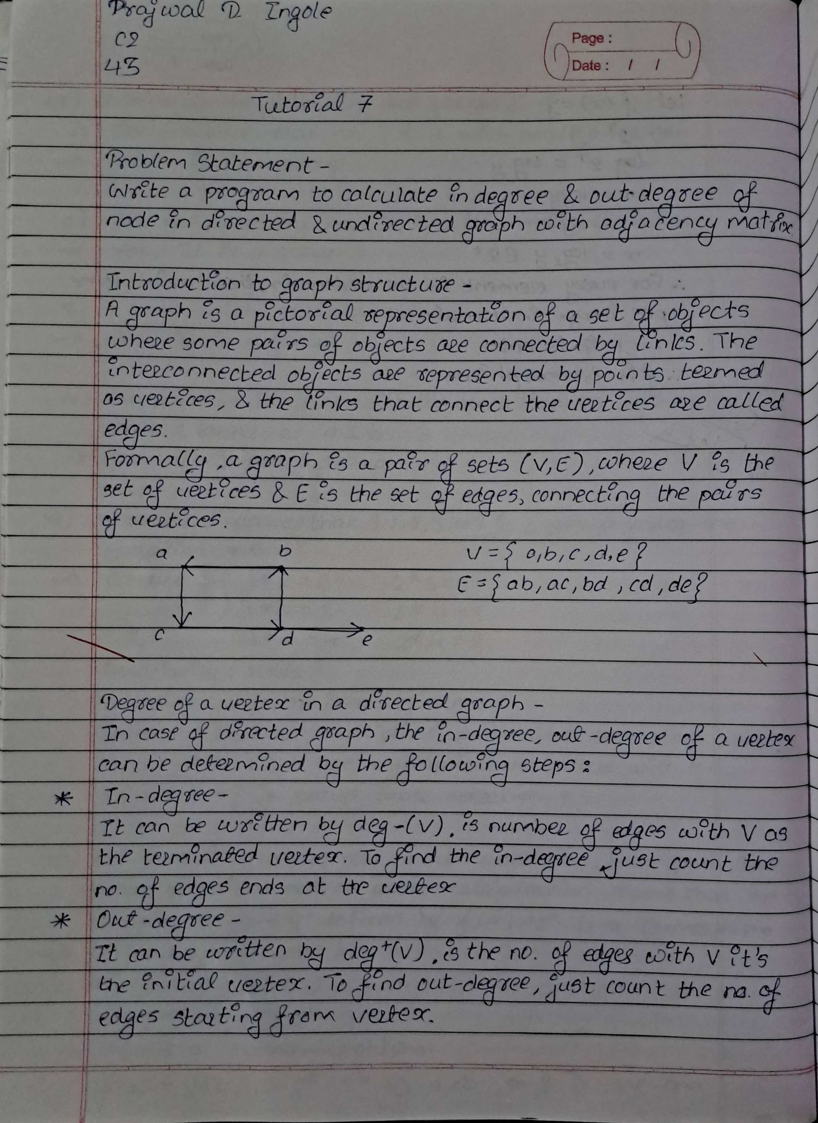

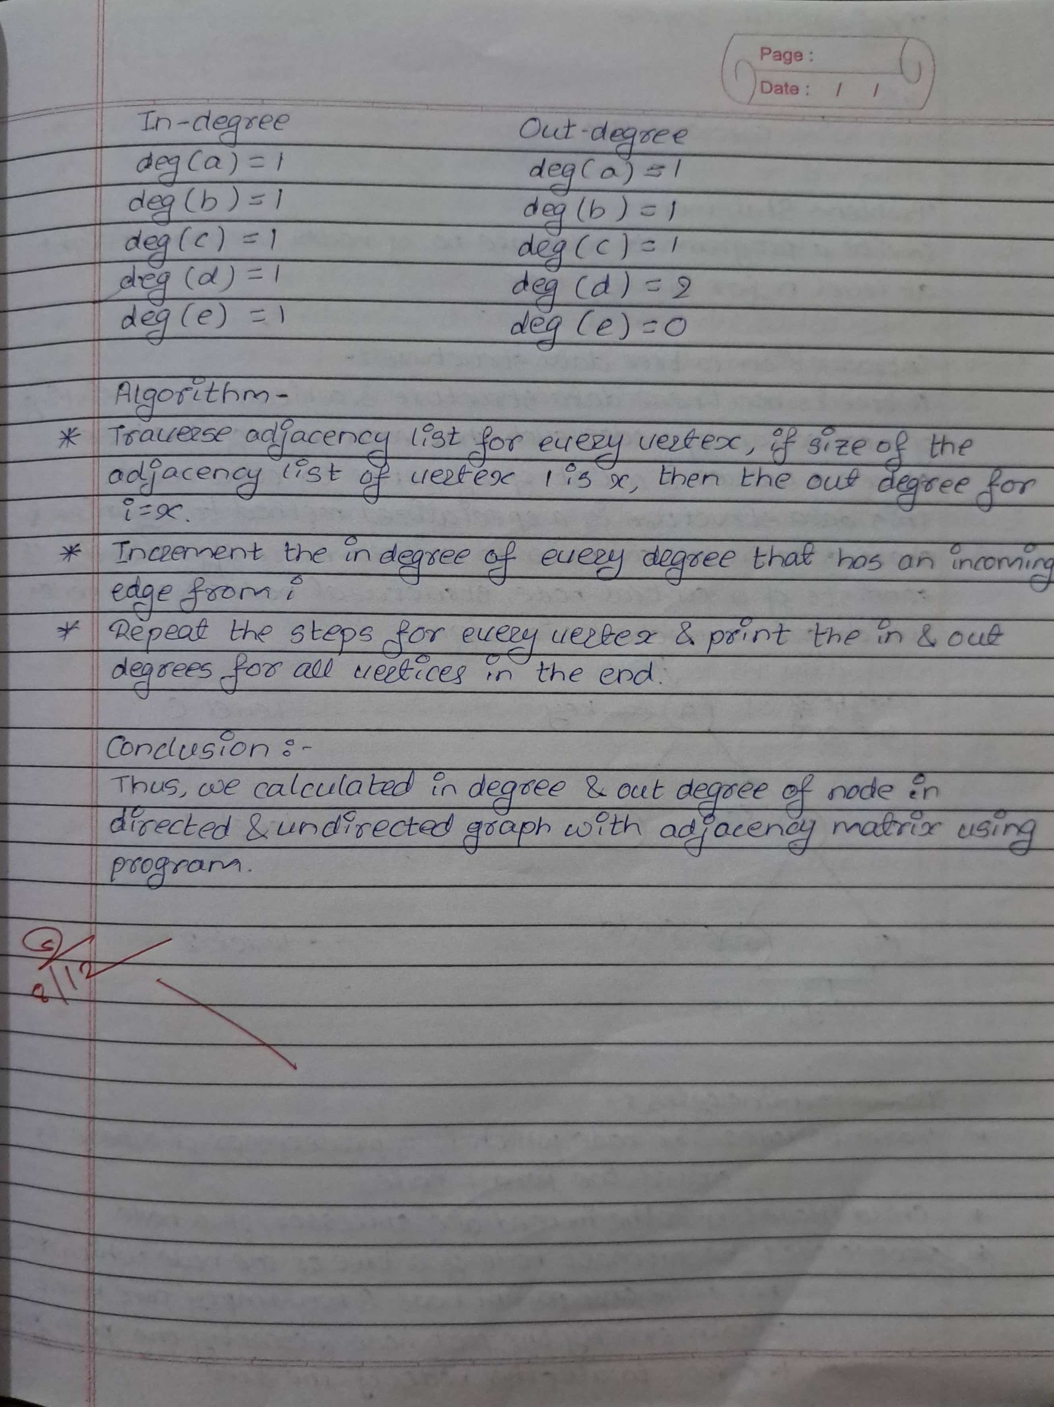

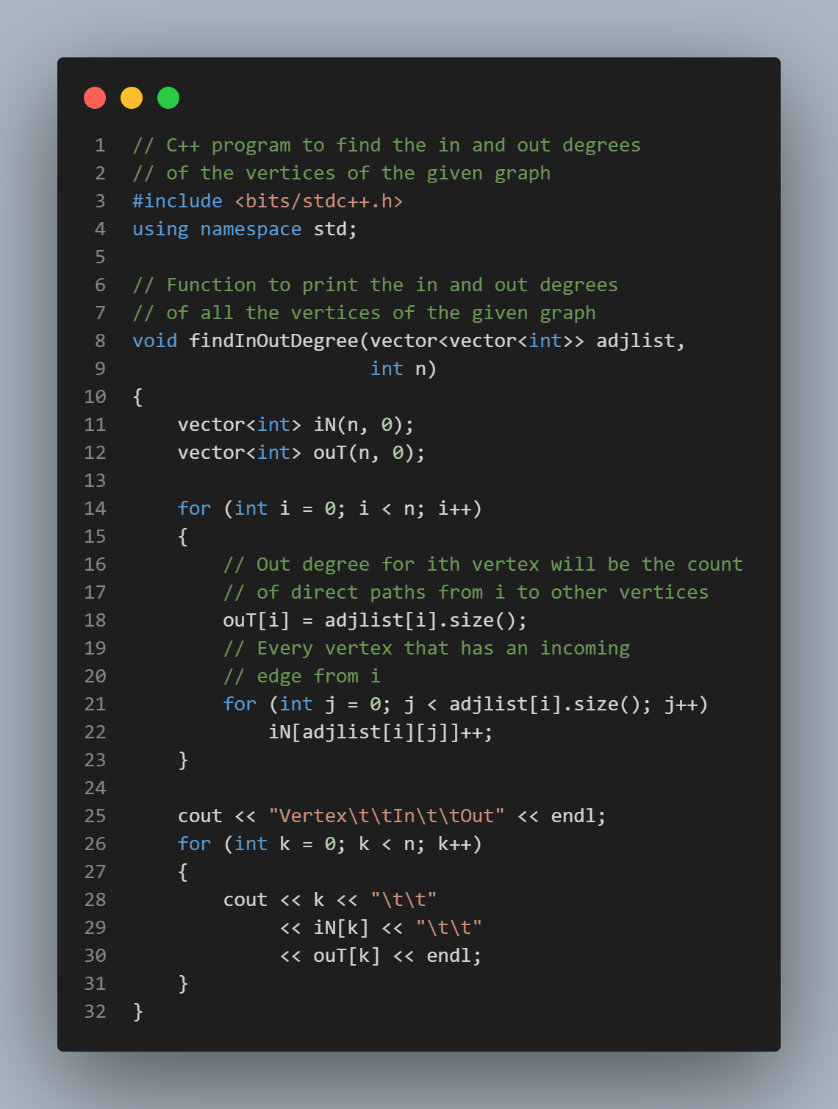Program Input:

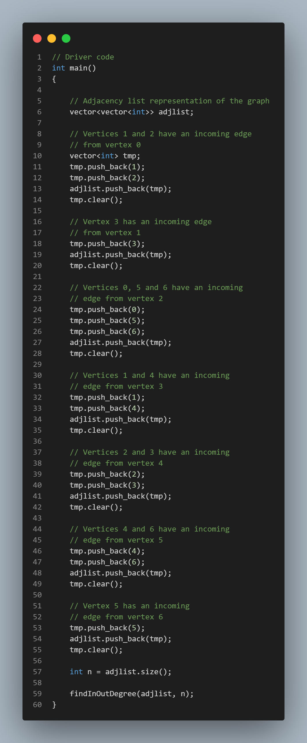

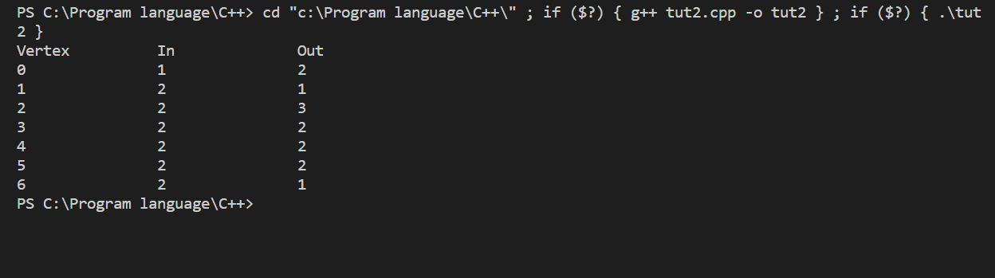Program Output: